**Task 03: CREATE Test AdHoc SQL - Daily Reports (CUBE)**

Script result

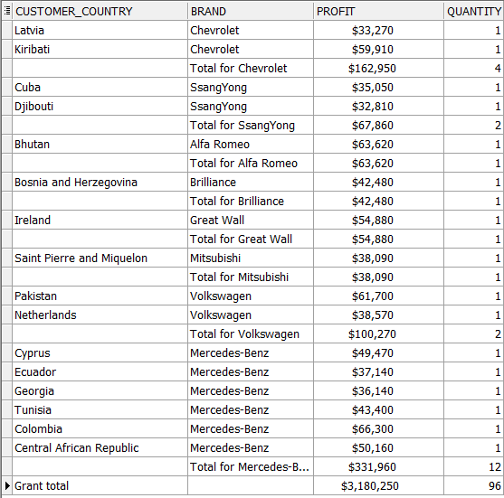

Report layout

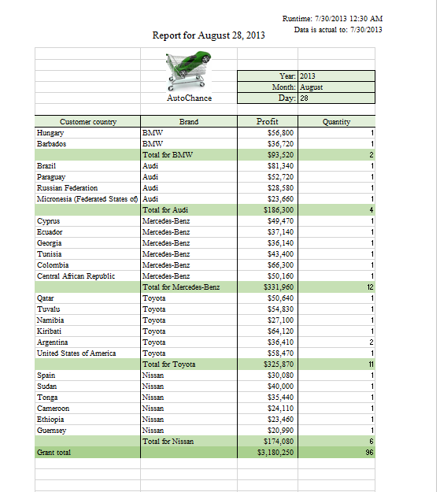

## Task 04: CREATE Test AdHoc SQL - Monthly Reports (ROLLUP & GROUPING SETS)

Script result

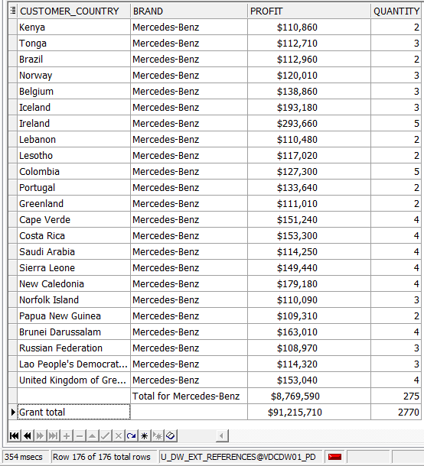

Report layout

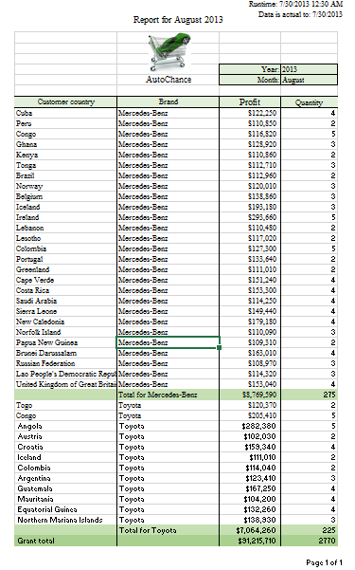

## Task 05: CREATE Test AdHoc SQL – ROLLUP by Time

